Von Schlieffen Plan

Long before WWI started in 1914, it was clear which country would support the other. Germany and Austria-Hungary already had an agreement dating back to 1878, Turkey joined up in 1914, followed by Bulgaria in 1915. Opposite these belligerent countries stood England and Fracne (Treaty of 1904), Russia (1907), Japan (1914), Italy (1915), Romania (1916), Greece (1917) and USA (1917).

Schlieffen Plan:
Every conflict had its neutral powers and the First World War was no exception. Holland was one of them, and the fact it would stay neutral was established long before WWI started. Not being connected by treaties of some kind to any of the surrounding countries had to emphasize this status. Neutral all the way. Even during the peace-conference of 1907, Holland made sure every nation present was aware of its neutrality and that it would be heavily defended if it ever came to that. Although special military laws introduced in 1912 had to make sure that more money was given to the expansion of Holland’s national defence system it was at the outbreak of war by no mean up to standard.

However, it wasn’t out of free choice that Holland kept her neutrality in 1914, although most history books will let you believe otherwise. Surprisingly enough, it had Germany to thank for that. The idea behind the so-called Schlieffen Plan, developed by one of Germany’s most devoted and unscrupulous Chief of General Staff, Count Von Schlieffen, was to invade France in one crushing blow, based on the fact France did not build up any of their defence systems along the Belgium border, thus leaving the backdoor to France width open. If this happened, Britain and Russia would be unwilling to carry on fighting.

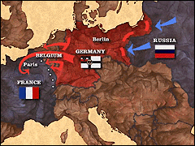
Von Schlieffen’s original plan
Von Schlieffen calculated it would take Russia at least six weeks to organize its large army for an attack on Germany. Schlieffen’s plan involved using 90% of Germany’s armed forces to attack France. When Helmuth von Moltke replaced Von Schlieffen as German Army Chief of Staff in 1906, he modified the plan by proposing that Holland was not invaded (as a result of this main port of Rotterdam remained open for business, which was also beneficial to Germany). The main route of the attacking force would now be through the flat plains of Flanders.

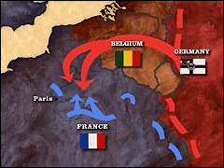
Schlieffen’s plan revised by H. von Moltke

Belgium also claimed to be neutral but learned very quickly that being neutral and defenceless is merely an invitation to any unscrupulous aggressor. A letter was sent by Prins Albert of Belgium to Wilhelm II, with the request to spare his Belgium from invasion. In answer, the Kaiser sent out an ultimatum to the King of Belgium (August 2, 1914). It stated Belgium could stay neutral as long as they let German soldiers march through Belgium. The answer was negative, and as a result, German soldiers fought their way through Belgium.

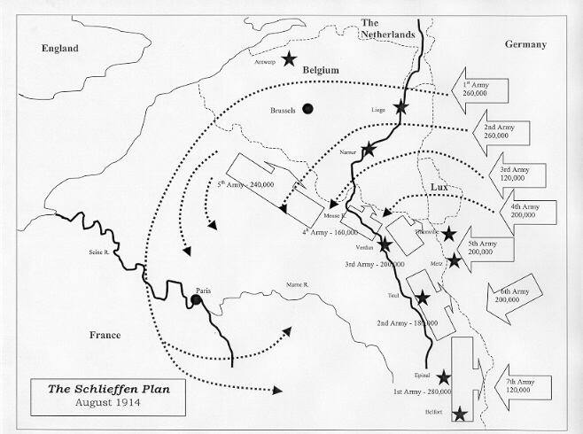

Countries only managed to preserve their neutrality because they were not in the path of the aggressor or whose neutrality gave an opportunity for trading, spying, or other activities. Switzerland preserved its neutral status purely based on the fact its banking facilities had more value than it would have been as a vassal state.

